Year 11 Chemistry
AECHE

Review

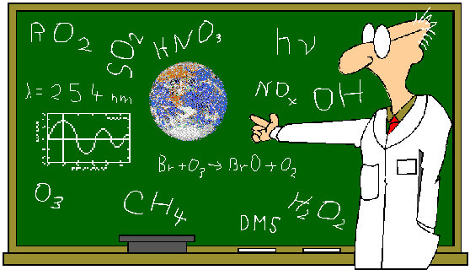

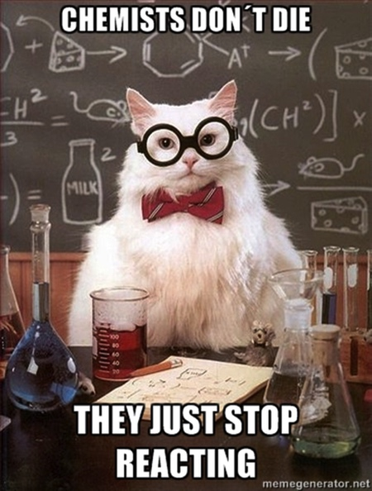

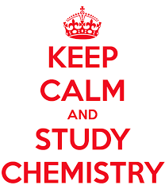

Elements:
- Substance made of only one kind of atom.
- Balance between protons (+ve charge) and electrons (-ve charge) – atom is neutral.
- Symbols for elements are taken from the periodic table.
e.g. iron – Fe; oxygen – O; magnesium – Mg.

Ions:
- Atoms that have gained or lost an electron to become charged.
- Atom losing electron it becomes positively charged, gaining electron negatively charged.
e.g. magnesium metal loses two electrons to become magnesium ion – Mg²⁺;
chlorine atom gains one electron to become chloride ion – Cl⁻
- Metals retain their original name but non metals often change e.g. chlorine atom becomes chloride ion.

Ionic Compounds:
- A joining of a metal and a non-metal atom to form an ionic compound.
- Metal loses one or more electrons to become positively charged.
- The non-metal will gain one or more electrons to become negatively charge.
- You must learn your valences to be able to write ionic formula.

Valances for Ionic Compounds (You must learn these)

Positive Valences
+1 |  | +2 |  | +3
Name | Formula | Name | Formula | Name | Formula
caesium ion |  | barium ion |  | aluminium ion
hydrogen ion |  | calcium ion |  | chromium(III)
lithium ion |  | cobalt(II) ion |  | iron(III) ion
potassium ion |  | copper(II) ion
rubidium ion |  | iron(II) ion
silver ion |  | lead(II) ion
sodium ion |  | magnesium ion
ammonium | NH₄⁺ | manganese(II)
 |  | nickel(II) ion
 |  | strontium ion
 |  | zinc ion
Negative Valances
-1 |  | -2 |  | -3
Name | Formula | Name | Formula | Name | Formula
bromide ion |  | carbonate ion |  | nitride ion
chloride ion |  | chromate ion |  | phosphate ion
cyanide ion |  | dichromate ion
dihydrogenphosphate |  | hydrogenphosphate
ethanoate (acetate) |  | oxalate ion
fluoride ion |  | sulfate ion
hydrogencarbonate |  | sulfide ion
hydrogensulfate ion |  | sulfite ion
hydroxide ion |  | oxide ion | O²⁻
iodide ion
nitrate ion
nitrite ion
permanganate ion

Writing Formula for Ionic Substances
STEP ONE:
Write the symbols for the name of the valance.
Example One:  Aluminium oxide  Al O | Example Two:  copper II carbonate  Cu CO₃ | Example three:  ammonium sulfate  NH₄ SO₄ | Example Four:  Calcium hydroxide  Ca OH

STEP TWO:
Write the number of the valance above the symbol:
Example One:  Aluminium oxide  3 2  Al O | Example Two:  copper II carbonate  2 2  Cu CO₃ | Example three:  ammonium sulfate  1 2  NH₄ SO₄ | Example Four:  Calcium hydroxide  2 1  Ca OH

STEP THREE:
Put brackets around any symbol that has more than one CAPITAL letter.
Example One:  Aluminium oxide  3 2  Al O | Example Two:  copper II carbonate  2 2  Cu (CO₃) | Example three:  ammonium sulfate  1 2  (NH₄) (SO₄) | Example Four:  Calcium hydroxide  2 1  Ca (OH)

STEP FOUR:
Cross out any that are number 1 AND any numbers that are the same number.
Example One:  Aluminium oxide  3 2  Al O | Example Two:  copper II carbonate  2 2  Cu (CO₃) | Example three:  ammonium sulfate  1 2  (NH₄) (SO₄) | Example Four:  Calcium hydroxide  2 1  Ca (OH)

STEP FIVE:
Cross the numbers over to the other symbol and place at the bottom following the other symbol.
DO NOT CROSS OVER ANY NUMBER THAT HAS BEEN CROSSED OUT.
Example One:  Aluminium oxide  3 2  Al O | Example Two:  copper II carbonate  2 2  Cu (CO₃) | Example three:  ammonium sulfate  1 2  (NH₄) (SO₄) | Example Four:  Calcium hydroxide  2 1  Ca (OH)
So that each symbol now like this
Example One:  Aluminium oxide  Al₂ O₃ | Example Two:  copper II carbonate  2 2  Cu (CO₃) | Example three:  ammonium sulfate  1  (NH₄)₂ (SO₄) | Example Four:  Calcium hydroxide  1  Ca (OH)₂

STEP SIX:
With symbols that have brackets, if you DIDN’T cross over a number to follow the brackets, remove brackets.
Example One:  Aluminium oxide  Al₂ O₃ | Example Two:  copper II carbonate  2 2  Cu CO₃ | Example three:  ammonium sulfate  1  (NH₄)₂ SO₄ | Example Four:  Calcium hydroxide  1  Ca (OH)₂

STEP SEVEN:
Join the two symbols together to make the formula:
Example One:  Aluminium oxide  Al₂O₃ | Example Two:  copper II carbonate  CuCO₃ | Example three:  ammonium sulfate  (NH₄)₂SO₄ | Example Four:  Calcium hydroxide  Ca(OH)₂

Do the following:
sodium chloride ______________________ copper II carbonate _____________________

magnesium phosphate __________________ potassium chloride ______________________

lead II nitrate _________________________ iron III carbonate _______________________

Common Reaction You Must Know.
- acid + base → salt + water
- acid + metal → salt + hydrogen gas
- acid + carbonate → salt + water + carbon dioxide gas
- acid + hydrogen carbonate → salt + water + carbon dioxide gas

Salts:
1. Salts consist of metal ions together with the negative ions from an acid.
- A salt is produced when a metal ion takes the place of hydrogen in an acid, for example:
Sodium metal + hydrochloric acid → sodium chloride + hydrogen gas
Sodium chloride is the salt.
- Naming the salt:
  - Hydrochloric acid: metal name plus chloride e.g. potassium chloride
  - Nitric acid: metal name plus nitrate e.g. calcium nitrate
  - Sulfuric acid: metal name plus sulfate e.g. copper II sulphate

Writing Simple Equations

Consider the following reaction:
hydrochloric acid + calcium calcium chloride + hydrogen gas

This can be written HCl + Ca CaCl₂ + H₂

- When the name of the element only is given, just write the symbol of the element – Ca.
- When the substance is a gas, you will usually write the symbol plus the small 2 - H₂.
- When a compound is given, you will need to write the formula – CaCl₂.
- You will be expected to know the common compounds:
- hydrochloric acid – HCl
- nitric acid – HNO₃
- sulfuric acid – H₂SO₄
- water – H₂O
- carbon dioxide – CO₂
- ammonia gas – NH_{3.}

Now write formula equations under the following word equations. You do not have to balance them at this stage. The first has been done to show you.

a. hydrogen gas + oxygen gas → water

H₂ + O₂ → H₂O

b. hydrogen gas + nitrogen gas → ammonia gas

c. hydrochloric acid + calcium hydroxide → calcium chloride + water

d. sodium + sulfuric acid sodium sulfate + hydrogen gas

e. sulfuric acid + potassium oxide → potassium sulfate + water

Balancing Chemical Equations

Rules for Balancing Chemical Equations:

Consider the reaction between hydrogen gas and oxygen gas.

RULE ONE  Identify the reactants and products where necessary. |  | Reactants: hydrogen gas and oxygen gas  Product: water
RULE TWO  Write down the word equations |  | hydrogen gas + oxygen gas water
RULE THREE  Write down the chemical formulas |  | H₂ + O₂ H₂O
RULE FOUR  Count the number of atoms of each element on each side of the arrow. If they are the same on both sides, the equation is balanced and complete. If not, move to rule five. |  | left hand side right hand side  2 H 2  2 O 1
RULE FIVE  Balance the number of atoms of each element on either side of the equation. This may require you to place numbers in front of reactants and/or products.  You can’t place a number in any other place in the formula. |  | Add a 2 in front of the H₂O  H₂ + O₂ 2H₂O  This balances the oxygen but now the hydrogen needs re-balancing. Add a 2 in front of the H₂.  2 H₂ + O₂ 2 H₂O
RULE SIX  Do a final check on the number of atoms on each side to see that they are balanced. |  | left hand side right hand side  4 H 4  2 O 2  This is now balanced.

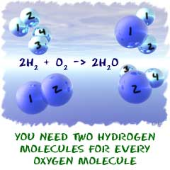

Another Example:
When magnesium is burnt in air, oxygen gas combines with magnesium to produce magnesium oxide.

Rule 1: reactants: oxygen gas and magnesium; products: magnesium oxide

Rule 2: magnesium + oxygen gas magnesium oxide

Rule 3: Mg + O₂ MgO

Rule 4: LHS RHS
1 Mg 1
2 O 1

Rule 5: balance oxygen by placing 2 in front of MgO:
Mg + O₂ 2 MgO

re-balance magnesium by placing 2 in front of Mg:
2 Mg + O₂ 2 MgO

Rule 6: LHS RHS
2 Mg 2
2 O 2 The atoms are now balanced on both sides.

Solids (s), liquids (l), gases (g) and aqueous solutions (aq).
To give an equation more meaning, subscripts are added to show the state (or phase) that the substance is in.
- Solids are shown as follows: (s).
- The only liquids are water and mercury and we use (l).
- Gases are shown as (g). Remember, gases of elements are often shown as diatomic (two atoms together) e.g. hydrogen gas is H₂, nitrogen gas is N₂, oxygen gas is O₂, chlorine gas is Cl₂ and fluorine gas is F₂. Other gases such as ammonia are not e.g. NH_{3 (g)}.
- Ions that are dissolved in water to become a solution of ions are labelled as aqueous (aq), for example,
Sodium hydroxide in water NaOH_{(aq)}
Magnesium chloride in water MgCl_{2 (aq)}
All acids e.g. hydrochloric acid HCl _{(aq)}

You must now write all equations showing these subscripts, for example:
Solid potassium carbonate + sulfuric acid potassium sulfate solution + carbon dioxide gas + water
K₂CO_{3 (s)} + H₂SO_{4 (aq)} K₂SO_{4 (aq)} + CO_{2 (g)} + H₂O_{(l)}
Write the completed balanced equations for the following – space has been left only if you wish to complete the word equation:

- Calcium metal + hydrochloric acid __________________________________________

__________________________________________________________________________
- magnesium hydrogen carbonate solution + sulfuric acid _________________________

__________________________________________________________________________
Exercise:
Balance the following equations. You should do all the working on a scrap of paper before you add the number to the equation. If the equation is already balanced write, “Balanced” next to it.

a. Zn + HCl → ZnCl₂ + H₂

b. Mg + HNO₃ → Mg(NO₃)₂ + H₂

c. KHCO₃ → K₂CO₃ + H₂O + CO₂

Exercise:
Write the formula equation below the word equation, then balance.
a. solid calcium oxide + water → calcium hydroxide solution

b. potassium hydroxide solution + carbon dioxide gas → potassium carbonate solution + water

Scientific Notation

Scientific notation or exponential notation is used to conveniently express very large or very small numbers.

Numbers are written so that there is a single, non-zero digit to the left of the decimal point, times the appropriate power of ten.

e.g. 6275 = 6.275 x 10³
0.006275 = 6.275 x 10⁻³

Exercise:
Express the following in scientific notation:

1. 0.00014 _______________

2. 0.000140 _______________

3. 367895 _______________

4. 56700000

5. 2500 (to two significant figures) _______________

6. 2500 (to four significant figures) _______________

Accuracy, Precision and Uncertainty

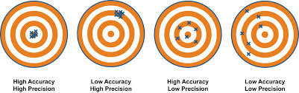

Looking at these diagrams, give a definition for accuracy and precision:

Accuracy -

Precision -

Every single measurement we take has an amount of inherent error or uncertainty.

There are two sources of error:
- Systematic error – this occurs in the same quantity in a series of measurements. For example if the needle on the voltmeter does not read zero when no voltage is present
- Random error – this occurs in every measurement as a result of variations in the measurement technique. A good example is parallax error.

When reporting errors in a measured quantity, either give the absolute error or the percentage error.
- Absolute error is the actual size of the error. It is given in the same unit as the quantity you are measuring.
- Percentage error is expressed as a percentage of the measured quantity and has no units.

Example

Measure 15 mL of a specific solution.

The absolute error associated with graduated measuring instruments is ± half of the smallest graduation.

Reliability and Validity

Data is reliable if it is repeatable or consistent. That means if you were to do the experiment many times over, it would yield identical results.

Data is valid if it fairly tests the hypothesis. In a valid experiment all variables are kept constant except those being investigated, all systematic errors have been eliminated and random errors are reduced by taking the mean of multiple measurements.

Below are the results of three different volume calculations:

Experiment A: volume = 14.7 mL ± 0.05 mL (± 0.3%)
Experiment B: volume = 15.0 mL ± 0.3 mL (± 2%)
Experiment C: volume = 11.2 mL ± 8.00mL (± 71%)

Which experiment is:
- Reliable but not accurate?

- Valid but not precise?

- Neither reliable nor valid?

Significant Figures

Significant figures give an indication to the precision of a particular measurement or given data.

They are not to be confused with decimal points.

For example, a student was asked to measure the volume of a liquid (in litres) and was told to express the answer to two significant figures.
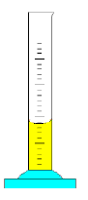
The students records a volume of 3.60 mL and converts this to 0.00360 L.

If the student rounded off the value to two decimal places, the volume would be 0.00 L!!!

To two significant figures, the volume would be 0.0036 L or 3.6 x 10⁻³ L.

If the mass of a solid is measured on a balance and the reading is 1.34 g, there are three significant figures. This measurement cannot be more precise than the instrument used to measure the quantity, that is, we cannot say that amount of solid weighs 1.342 or 1.344 g.

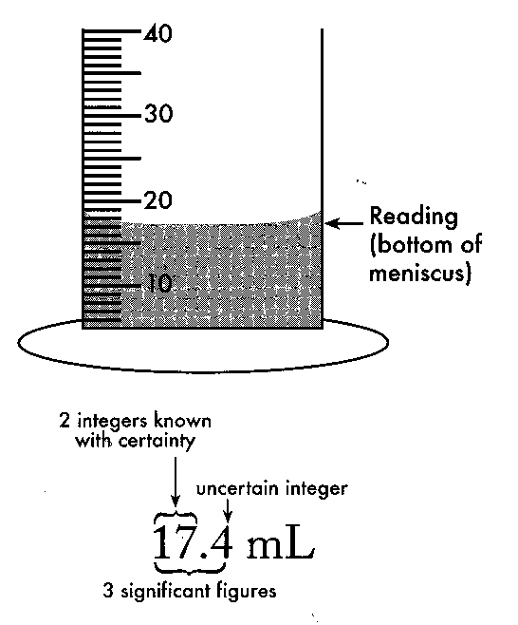
Using the diagram on the left, we can see that there is somewhere between 17 and 18 mL because the meniscus is lying between these two lines.

The first two digits are known with a high degree of certainty.

The next number is an educated guess.

17.4 mL has three significant figures – all the numbers that are known with certainty, plus one more.

More accurate equipment will give more precision and more significant figures.

The rules for determining how many significant figures a number has are:
- Figures other than zero are always significant
- Any zeroes after the decimal point are significant
- Any zeroes at the end of a number with no decimal point are not significant
- Zeroes between two other significant figures are significant
- Zeroes used for spacing the decimal point are not significant
- Fractions have an infinite number of significant figures because they are exact.

1.46 0.106 1.10 have __________ significant figures

2.100 x 10³ 1.476 0.02600 have __________ significant figures

8.1 0.00026 26 have __________ significant figures

NOTE: putting the number into scientific notation can avoid confusion.

Examples

Number | Significant Figures | Rules applying to the number
24
3007
12.30
0.0072
100
100.0
½

Answers to questions should be expressed to a suitable number of significant figures.

Calculate the density of a liquid (in g/L) if the mass was 30.2 g and the volume was 24.2 mL

If this was given as the answer, it would suggest that we knew the exact density to 5 decimal places or to 9 significant figures (which is not the case).

An answer to a question can only be as accurate as the least accurate value in the question.

Both of the values in the question have three significant figures, so the answer must be expressed as three significant figures

i.e. 1250 g L⁻¹ (g/L) or 1.25 x 10³ g L⁻¹

When performing calculations, the answer can only be expresses in terms of the accuracy of the original values.

When multiplying or dividing, give the answer to the least number of significant figures as in the question.

Complete the following problems and give your answer to the appropriate number of significant figures:

- 2.56 x 8.319 =

- 12.01/44.01 =

- 20 x 1.008 =

When adding or subtracting, give the answer to the least decimal places in the question.

- 2.56 + 8.319 =

- 44.01 – 12.01 =

Round the following to three significant figures:

1.294 _______________

0.06437 _______________

21.65 _______________

21.75 _______________

3.997 _______________

Review of Lower School Chemistry:
- Write the symbol and valance for each of the following ions (don’t look at your valence sheet):
a. sodium _________ b. chloride _________ c. phosphate ________
d. ammonium __________ e. nitrate __________ f. carbonate _________
g. copper II ________ h. potassium _______ i. sulfate ___________
2. Name the following including if an atom, gas or ion
Na ____________________________ Na⁺ ______________________________
Cl: ____________________________ Cl⁻ _______________________________
Cl₂ ____________________________ Mg ______________________________
NH₄⁺ __________________________ NH₃ _____________________________
H _____________________________ H⁺ _______________________________
H₂ ____________________________ Hg ______________________________
- Write the formula for the following compounds:
a. copper II sulfate ________________ b. Aluminium sulfate ________________
c. hydrochloric acid _______________ d. caesium carbonate _______________
e. oxygen gas ____________________ f. strontium nitrate ________________
g. magnesium oxide _______________ h. sulfuric acid ____________________
- Name these formulas Write these formulas
Pb(NO₃)₂ _______________________________ copper II chloride ___________________
Fe₂O₃ __________________________________ magnesium hydroxide _______________
AgNO₃ _________________________________ iron II sulfate ______________________
(NH₄)₂SO₄ ______________________________ zinc chloride _______________________
HCl ___________________________________ calcium phosphate __________________
- Balance the following equations:
a. Pb(NO₃)_{2 (aq)} + KI_{(aq)} → PbI_{2 (s)} + KNO_{3 (aq)}
b. NaHCO_{3 (s)} → Na₂CO_{3 (s)} + H₂O _{(l)} + CO_{2 (g)}
c. KClO_{3 (s)} → KCl _{(s)} + O_{2 (g)}
Write the balanced equations for the following reactions. The first has been done for you to illustrate what to do. You must show the state. For the moment you do not need to write ionic equations.

6. Copper II chloride solution + sodium carbonate solution → solid copper carbonate + sodium chloride solution
CuCl_{2 (aq)} + Na₂CO_{3 (aq)} → CuCO₃ _{(s)} + 2NaCl _{(aq)}

7. Barium metal + hydrochloric acid → Barium chloride solution + hydrogen gas
____________________________________________________________________________
8. Copper II carbonate solid + sulfuric acid → copper sulfate solution + carbon dioxide gas + water
____________________________________________________________________________
9. Sodium hydroxide solution + sulfuric acid → sodium sulfate solution + water
____________________________________________________________________________
10. Calcium hydrogencarbonate solution + nitric acid → calcium nitrate solution + carbon dioxide gas + water
____________________________________________________________________________
11. Nitric acid + lithium hydroxide solution → lithium nitrate solution + water
____________________________________________________________________________
12. Solid Magnesium oxide + water → magnesium hydroxide solution
____________________________________________________________________________
13. Aluminium metal + oxygen gas → solid aluminium oxide
____________________________________________________________________________
14. Potassium chloride solution + lead nitrate solution → solid lead chloride + potassium nitrate solution
____________________________________________________________________________
15. Hydrogen gas + oxygen gas → water
____________________________________________________________________________
16. hydrogen gas + nitrogen gas → ammonia gas
____________________________________________________________________________
17. solid calcium carbonate + heat → solid calcium oxide + carbon dioxide gas
____________________________________________________________________________
18. copper sulfate solution + potassium carbonate solution → solid copper carbonate + potassium sulfate solution
____________________________________________________________________________
19. Iron metal + oxygen gas → solid iron III oxide
____________________________________________________________________________
20. Barium chloride solution + ammonium sulfate solution → solid barium sulfate + ammonium chloride solution

____________________________________________________________________________

Some important molecular substances

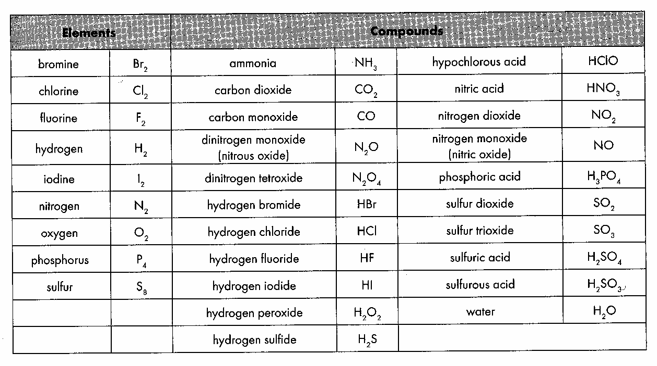

Mini Test (25 marks total)

MULTICHOICE SECTION:

- The correct formula for iron III ethanoate (acetate) is
- Fe(CH₃COO₃)
- Fe₃CH₃COO₂
- Fe(CH₃COO)₃
- Fe₂CH₃COO

- Which of the following is unlikely to exist?
- Fe₃(PO₄)₂
- Ca(OH)₃
- MgCl₂
- AlPO₄

- Which of the following is a salt?
- potassium chloride
- hydrochloric acid
- carbon dioxide
- sodium hydroxide

- An unknown metal X has a carbonate with the formula X₂CO_{3.} The charge on the metal ion is:
- +3
- –2
- –1
- +1

- From the following set of equations, select the one which represents the reaction of an acid and a base.
- Magnesium + sulfuric acid magnesium sulfate + hydrogen gas.
- Hydrogen nitrate solution + copper II oxide copper nitrate + water.
- Carbon dioxide + water hydrogen carbonate.
- Potassium hydroxide solution + hydrochloric acid potassium chloride + water.

6. The CORRECT balanced chemical equation for the reaction between hydrogen gas and chlorine gas is:
- H₂ + Cl₂ → 2HCl
- H + Cl → HCl
- H + Cl₂ → HCl₂
- H₂ + Cl → H₂Cl

  - The equation below represents the formation of iron III oxide from iron metal and oxygen gas.

X Fe_{(s)} + Y O_{2 (g)} Z Fe₂O_{3 (s)}

The values of X, Y and Z in order, in the correctly balanced equation is:
- 2, 3, 2
- 1, 2, 3
- 4, 3, 2
- 4, 2, 3

  - A solution has a pH of 10. Which of the following are correct?

  - The solution is an acid.
  - The solution is a base.
  - The solution is neutral.
  - Not enough information to answer the question.
MULTICHOICE SECTION:
Place a cross (X) on the one correct answer. (8 marks)
1. a b c d 5. a b c d
2. a b c d 6. a b c d
3. a b c d 7. a b c d
4. a b c d 8. a b c d
SHORT ANSWER SECTION:
Answer all questions in the spaces provided. (17 marks)

- Name any one element which: (2 marks)
a. loses 2 electrons to become an ion: _____________________________
b. gains 2 electron to become an ion: _____________________________

- Write down the name of the following. Name must include must indicate which valance ion if ion has more than one valance number. (2 marks)

  - CuC₂O₄ ____________________________________________________________________
  - Fe₂(CO₃)₃ ____________________________________________________________________
- Write down the chemical formula for the following: (4 marks)
a. iron III dihydrogenphosphate ______________ c manganese II dichromate _________
b. barium hydroxide _______________ d. rubidium sulfide __________________
- Balance the following equations. (3 marks)

- ZnCO₃ + HCl → ZnCl₂ + H₂O + CO₂

- H₃PO₄ + Ca(OH)₂ → Ca₃(PO₄)₂ + H₂O
- KClO₃ → KCl + O₂

- Write the balanced chemical equations for the following reactions. You must show the state e.g. if solid, liquid or gas. (6 marks)

  - zinc carbonate solution + hydrochloric acid → zinc chloride solution + water + carbon dioxide gas

  - hydrogen sulfide gas + oxygen gas → water + sulfur dioxide gas

  - Solid sodium hydrogencarbonate → solid sodium carbonate + carbon dioxide gas + water

